

SEYCHELLES POSTAL SERVICES

ANNUAL REPORT
2021

Contents

1. Introduction
2. Universal Postal Services
3. Administration
4. Operations
5. Finance
6. Conclusion

1. INTRODUCTION
Seychelles has signed the declaration for the provision of Universal Postal Services with the Universal Postal Union (UPU) to provide these services. This means offering an affordable option and being able to deliver all forms of mail.

2. UNIVERSAL POSTAL SERVICES
Provision of postal services of a specified quality on Mahe, Praslin and La Digue at an affordable price:

- Letters up to 2kg
- Parcels up to 30 kg.

3. ADMINISTRATION
Personnel:
- 101 employees
- 21 left
- 13 were hired, all in Operations department.
- High turnover of postmen, drivers and postal assistants as the salaries are very low in comparison to other industries.
- New CEO for SPS started mid-June.
- New strategy plan put in place.
- SPS moved back to its previous premises on La Digue and saved on rent.
- Operations space in Victoria has outgrown it purpose due to increase in ecommerce, layout is not a clear mail flow and is open to issues of loss, misplacement, damage and theft.

- Safety officer has provided a report of the shortcoming of Seychelles Postal Services. It would close it down due to the level of risk. Too many corridors, with limited space, naked wires, paper everywhere, mail bags outside SRC office.

4. OPERATIONS
The following should be noted:

Due to the Pandemic and global lockdowns, there were delays in receiving and sending mail.

Local mail volume declined; ecommerce remains a constant.
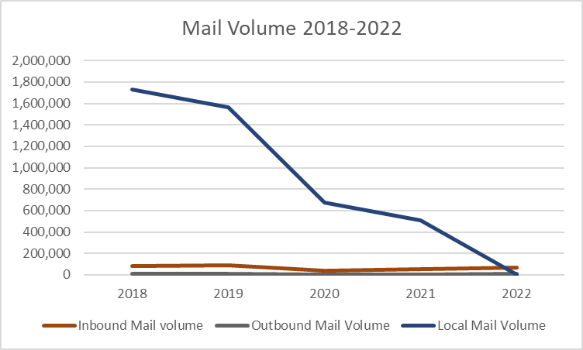
Due to staff with COVID and self-isolation policies there were not enough staff working at a steady pace and flow, and there was constant disruption to work stream.

Toward the end of the year, SPS started a mail clear up operation. There was mail from pre pandemic that had not been delivered, missent items that had not been forwarded on to their correct destinations, outbound mail not sent out due to destinations still closed and limited flight availability and old mail not collected by customers. Mail held by customs and dead letters unopened.

- Seychelles Postal Services does not meet UPU delivery standards.

- There were serious delays in the delivery of small packets due the new Parcel Management System, which only relies on text message collection advise.

- Decline in standard of letter home delivery due to lack of customer knowledge, unclear addressing and unmotivated postmen,

- Unable to deliver small packets due to SRC requirements.

- Delay in delivery of small packets due to disorganized IMPC area, bad layout and lack of training in reading mail processing functions and systems.

- Tracking system for parcels and registered items at times not functioning properly due to not enough Wi-Fi bandwidth to support the number of systems in use.

- New parcel management system not integrated with UPU IPS system, so workload on teams is doubled. Repeating similar tasks in 2 systems

- When IPS is not updated with delivery of item, SPS income decreases and so does its terminal due rates the following year.

- Poor knowledge of IPS system due to high staff turnover and remaining staff not prepared to share knowledge,

- Poor and negative mindset amongst staff due to personal issues.

- Lack of a National Addressing System making delivery of letters difficult. Addresses are not full proof.

- Customer don’t always want to receive mail, especially official mail.

- Returned mail (undelivered) at 5%.

- The implementation of the National Addressing System delayed due to the naming of roads on Mahe, Praslin and La Digue. Government provided a budget of R2.9 million.

- Prices of mail conveyance, mail accessories increased.

- Restructuring process started.

5. FINANCE
The following points are to be noted:

Postage income decline in past 2 years.
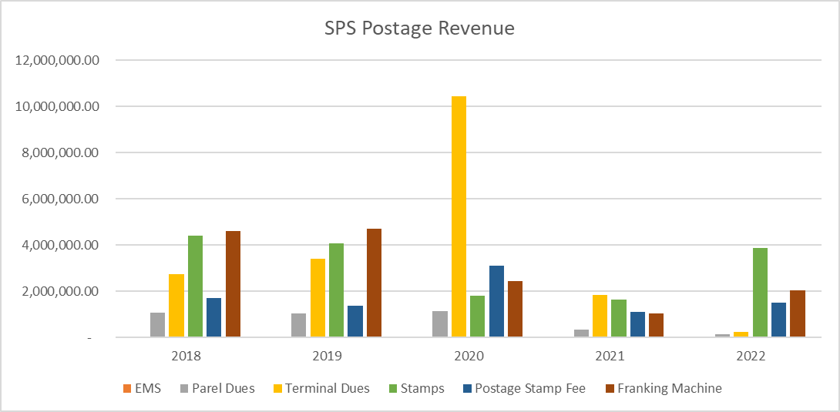

- Government paid Seychelles contribution to the Universal Postal Union.

- Government grant of 15 million was used to pay:
- Basic salaries
- Allowances

- Continuous increase in labour cost

- Postal rates have to be reviewed and increased to cover cost of services and goods.

- Expenditure is being controlled.

- Looking at new ways of generating additional revenue and diversifying services.

- SPS is not treated the same as private couriers, when in essence all are logistics businesses.

- Handling Fee approved by cabinet in September 2021, however, was asked to hold off introducing until service improved. However, due to the level of old mail found undelivered the fee has been put on hold.

- Terminal dues calculation not correct, some countries have not paid since 2018. Accruals had not been updated.

- Debtors list is being reviewed.

6. CONCLUSION

The profitability of Seychelles Postal Services remains a challenge, however, it is not impossible, the government needs to support SPS by allowing changes that alter traditional ways of working to be tried and tested.

A business plan is to be developed for the next 3 years to see where the company goes from here.

Government assistance will continue to be required in the next few years but not at the same amount.

August 2022

